| **PROJECT INFORMATION** | | | |
| --- | --- | --- | --- |
| ***Report Description:*** | **Literature review for EEG signals** | | |
| ***Professor:*** | **Prof.** [**Gady Agam**](mailto:agam@iit.edu) | ***Tools used/work done:*** | 1. **Literature Review on feature extraction of EEG** 2. **CITI program - Completed** |
| ***Report prepared by:*** | [**Noviya Balasubramanian**](mailto:nbalasubramanian@hawk.iit.edu) |
| ***HAWK ID:*** | **A20541236** |
| ***Report no:*** | **3** | ***Report Date:*** | **9/6/2024** |

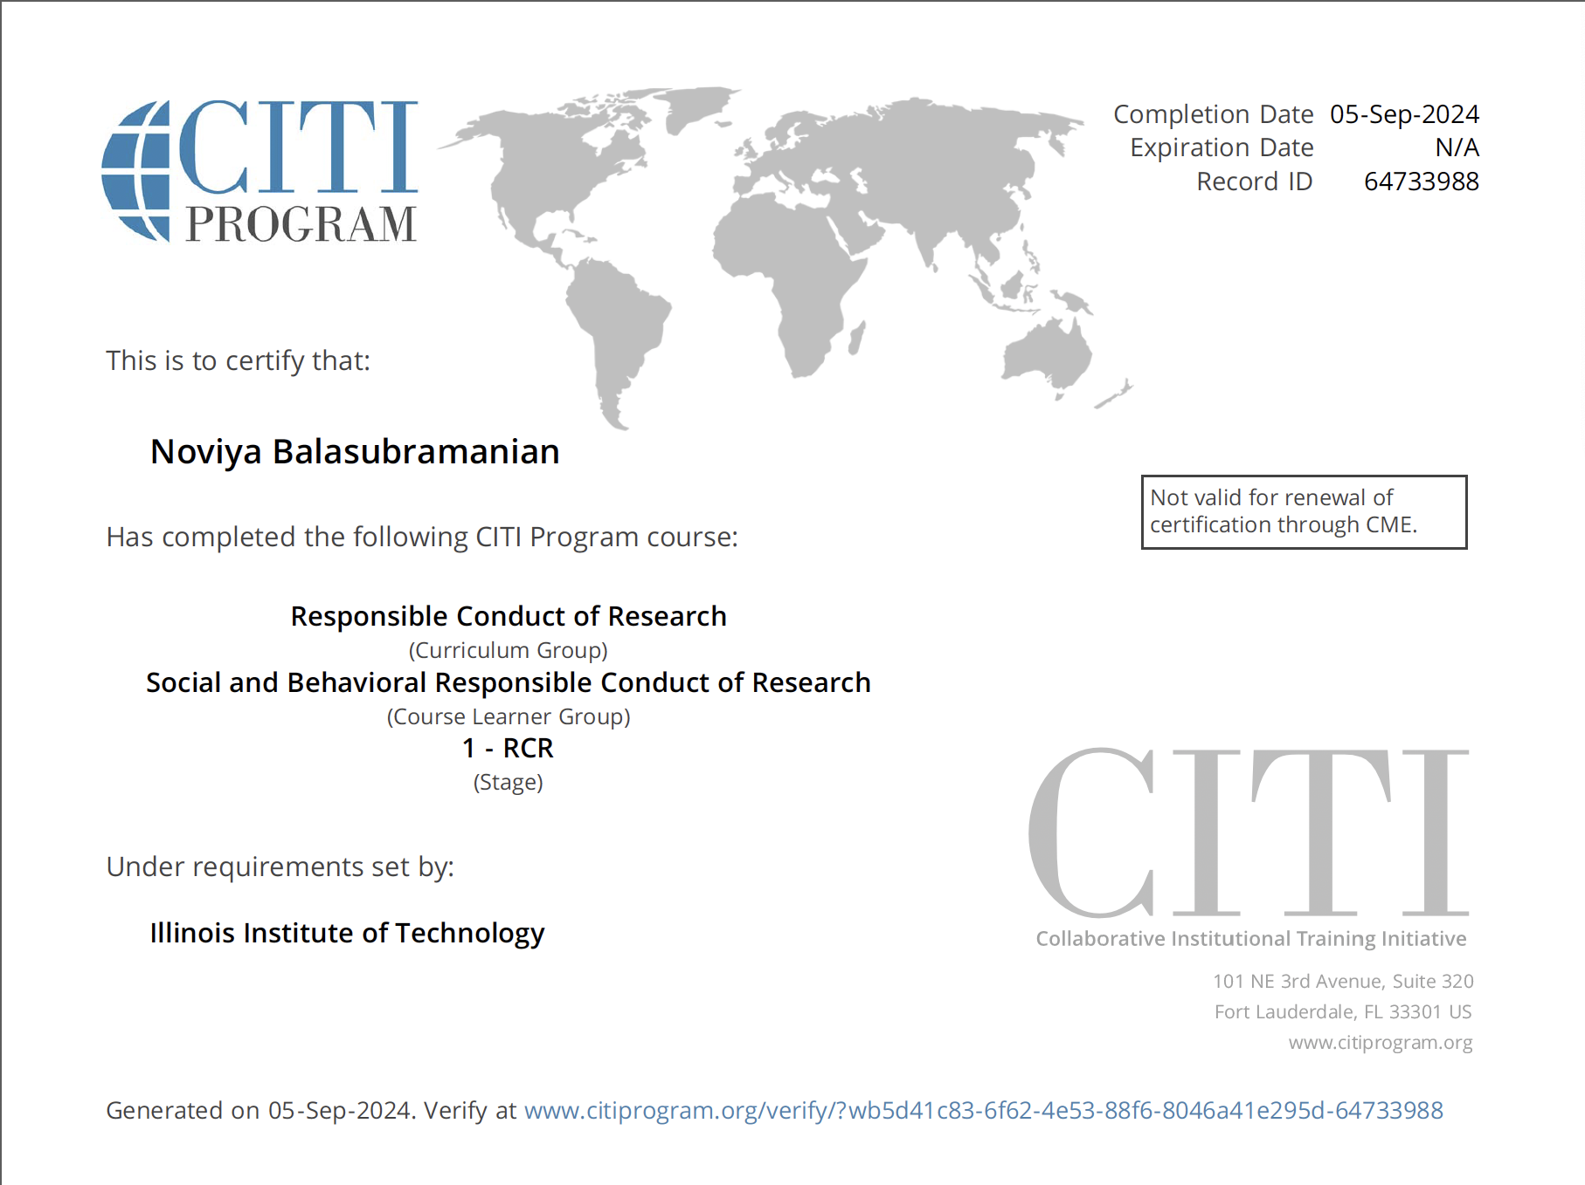

**Work done:**- Completed the CITI program trainings

* Conducted a literature review focused on a problem statement

[1]S. Liu *et al*., "**3DCANN: A Spatio-Temporal Convolution Attention Neural Network for EEG Emotion Recognition**," in *IEEE Journal of Biomedical and Health Informatics*, vol. 26, no. 11, pp. 5321-5331, Nov. 2022, doi: 10.1109/JBHI.2021.3083525.

The 3D convolutional attention neural network (3DCANN) consists of two parts: 3DCNN feature extraction and EEG channel attention weight learning. The 3DCNN extracts spatial and temporal characteristics of emotional states, while the attention module learns the weight matrix of electrodes affecting emotions.

* Input matrix dimensions: 5×62×200×1 (5 seconds, 62 electrodes, 200 sampling points, 1 channel)
* Convolution layers: 2 with kernel size 5×5×5
* Pooling layers: 2 with window size 2×1×2
* Attention module: Includes permute layers, dense layer (softmax activation), and multiply layer
* Optimizer: Adam with bias correction
* Loss function: Cross-entropy

[2]E. Debie et al., "**Multimodal Fusion for Objective Assessment of Cognitive Workload: A Review,**" in IEEE Transactions on Cybernetics, vol. 51, no. 3, pp. 1542-1555, March 2021, doi: 10.1109/TCYB.2019.2939399.

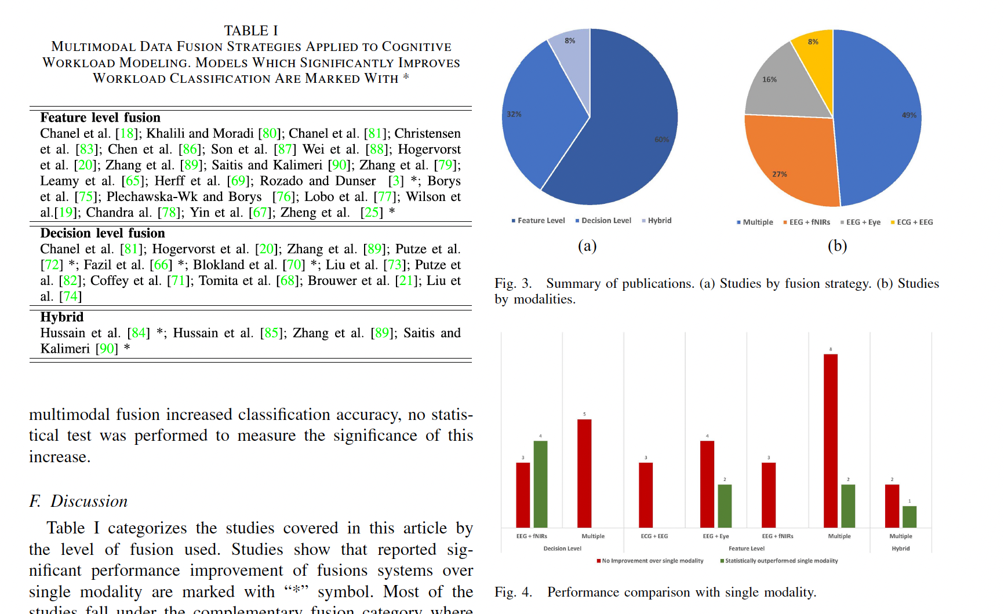

“*fNIRS is commonly used*

*in this regard to measure the amount of effort exerted in a given*

*brain region in response to a given task.*

“

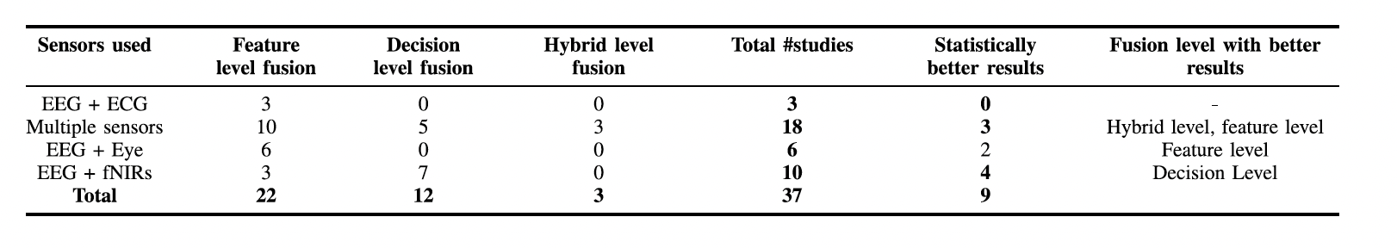

* *fusion at the decision level - explore more on this*
* *Combining EEG with pupillometry comes next where two out of six studies reported statistically significant improvement over single modality; the two studies considered fusion of EEG and pupillometry at the feature level.*

***Will start with working on processing the EEG signals once after I get the access to the data***

Suggested problem statement:  
1. **Fusing Different Modalities to Capture the cognitive load (Exam data) or attention(Training)**

* **Decide the level of fusion**
* **Fusion approaches**
* **Additional: Capture cognitive and emotional states**

**2. Feature Extraction: Finding a Novel Approach:**

**3. A comparison study: EEG based detection vs Pupil based detection of attention**

* **Assumption: Pupil will outperform the EEG**

**2 state: Impasse, Aha!**

**Handle In motion and stationary   
  
Channels for movement -   
Search term   
Classification**

**Search literature paper - Xiaoting**